California Community College League

Data Analysis and Review of Performance Funding Project

4-1-19
Summary
The Community College League of California seeks a draft scope of work from a third-party to conduct technical analyses and simulations on the California Community Colleges’ new Student Centered Funding Formula. Enacted in the 2018-19 Budget Act, the Student Centered Funding Formula (SCFF) consists of three components: 1) Base Allocation— Enrollments (FTES), 2) Supplemental Allocation—Counts of low-income students, and 3) Student Success Allocation—Counts of outcomes with higher funding for outcomes of low-income students. The new formula will be phased-in over a three-year period with potential for adjustment in that period.

Approach & Project Scope
The following is an overview of the services that will be provided, along with our approach:

- Early in the project, meet with the members of the Chief Executive Officers (CEO) Student Centered Funding Formula Taskforce that is overseeing the review.
Analytica will meet with the CEO Student Centered Funding Formula Taskforce (Taskforce) to identify potential modification to the California Community Colleges Student Centered Funding Formula adopted by the state of California in 2018. Analytical will help simulate the modification prioritized by the Taskforce and provide supports such as maintain the model, identifying data sources, and reviewing simulations with the Taskforce.

- Support Community College League of California’s effort to acquire necessary data
On behalf of The League we will meet with the appropriate parties to acquire any necessary data that is required for this work effort. As part of the data acquisition we will confirm the integrity and quality of the data, how it is updated and what frequency, where the data was sourced from and perform a review of the data using data analysis tools. If there are any data quality issues we will look for ways to correct this and create solutions on how to remedy the issues.

- Build a database (preferably 10 years of data) containing the data that will be utilized in the analyses and modeling efforts
Analytica is not just a data analysis firm, we are a team of technical data experts with over 10 years of expertise in database architecture and database development. We will utilize the appropriate cost effective database technology that The League currently uses to develop this database and populate it with 10 years of data. We will provide documentation of the data model including information on all tables and fields within the database.

- Analyze individual components
We will analyze the data, including providing any time series analyses to determine variability. We will investigate all variables and what their effect is on the outcome and run all possible simulations. Our data science team will utilize the appropriate statistical methods and create a report of findings to present to The League and all stakeholders.

- Create a model that allows investigation
Our model will be dynamic, flexible and configurable to allow multiple inputs so that changes can be made and results can be visualized. We will develop a dashboard where these inputs can be dynamically entered and visualized by users internal to The League.

- Meet with Task Force to review findings, conduct “on the fly” investigation and identify additional required work
We will present our findings in an official report and also develop a dynamic dashboard where changes to the model can be made real-time.

Sample Work

Sample Work – California Department of Public Health, Center for Healthcare Quality

Project Mission:
CDPH’s mission is to improve patient care and quality within the State of California. The Center for Healthcare Quality Program was in need of a firm to help improve its operations of the Licensing & Certification Unit.

Project Goal:
Create a model that allows the Licensing & Certification unit’s Completed Applications Board (CAB) to see how the backlog of open cases would be affected if applications rose by changing several variables. The model that we developed allows users to select a given percentage starting on a specific date, simulating the hiring of additional analysts. Please see screenshot of the dashboards we developed to help visualize this model below.

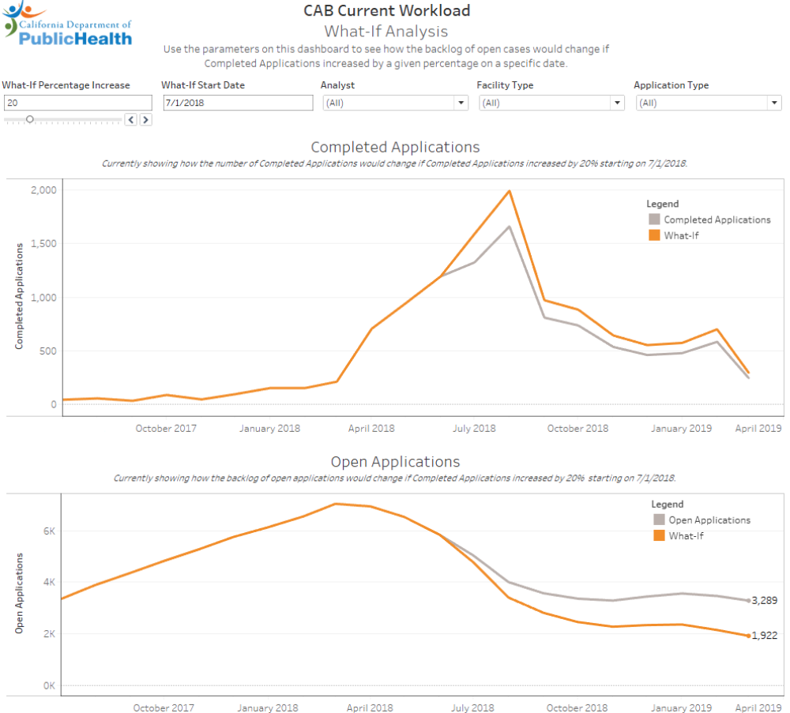

Tasks
Item | Estimated Hours
Initial Review & Model Recommendations | 35
Acquire Data & Develop Database | 30
Analyze Data and Create Dynamic Model | 30
Support, Meetings & Presentations | 30

